1. vagrant@vagrant-ubuntu-trusty-64:~$ sudo mkdir -p /db/active1/data /db/active2/data /db/passive1/data
2. On three separate cmd windows:
3. vagrant@vagrant-ubuntu-trusty-64:~$ sudo mongod --port 27021 -dbpath /db/active1/data --replSet testset --smallfiles --oplogSize 128
4. vagrant@vagrant-ubuntu-trusty-64:~$ sudo mongod --port 27022 -dbpath /db/active2/data --replSet testset --smallfiles --oplogSize 128
5. vagrant@vagrant-ubuntu-trusty-64:~$ sudo mongod --port 27023 -dbpath

/db/passive1/data --replSet testset --smallfiles --oplogSize 128

1. On the fourth cmd window:

mongo 127.0.0.1:27021

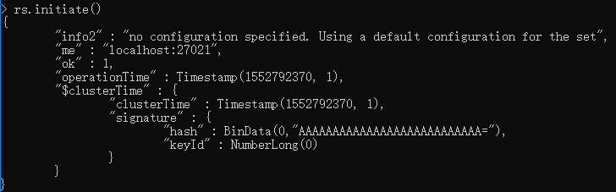

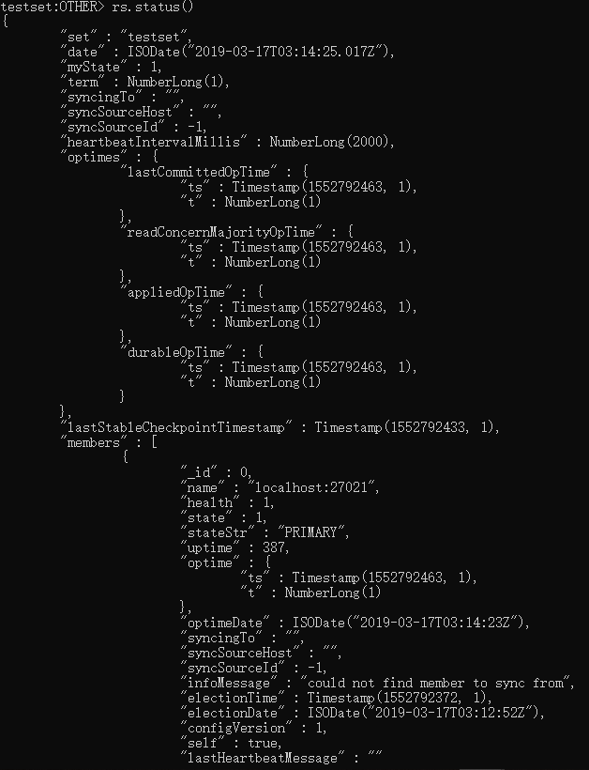

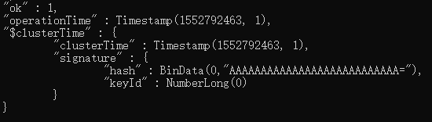

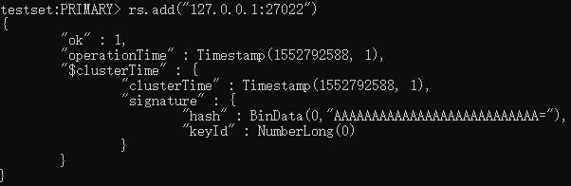

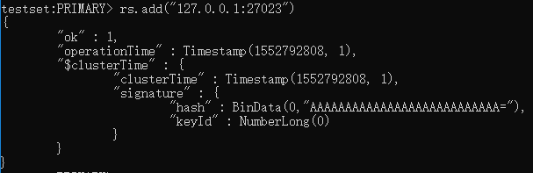

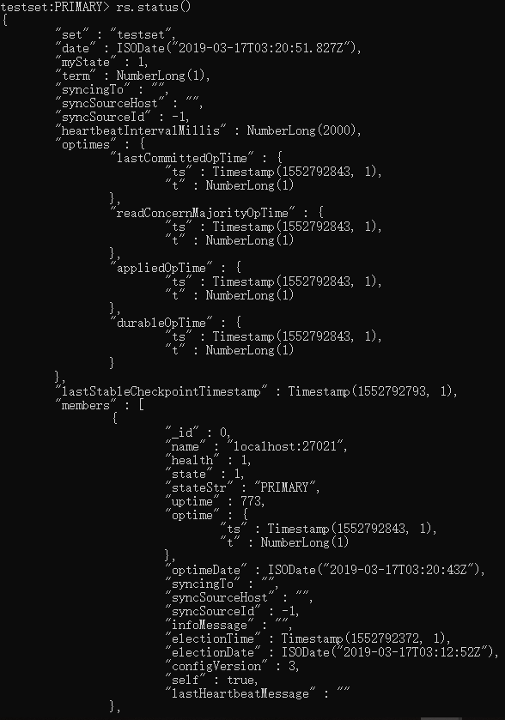

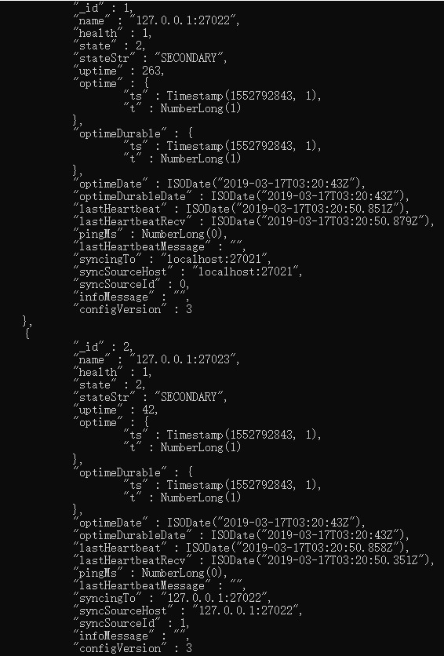

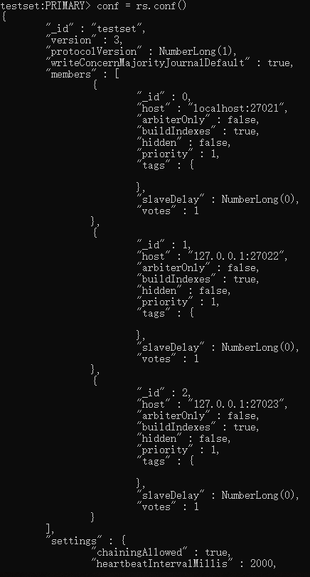

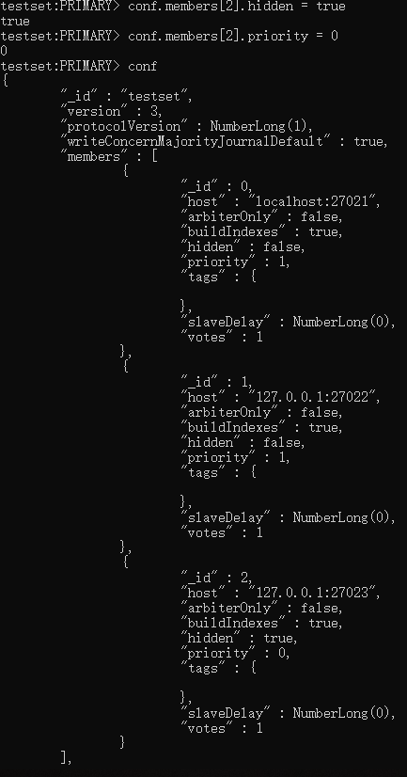

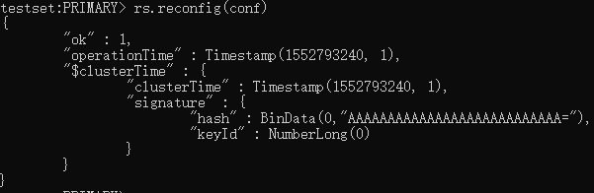

1. Add arbiter.

On the fifth cmd window:

(1) vagrant@vagrant-ubuntu-trusty-64:~$ sudo mkdir -p /db/arbiter1/data

(2) vagrant@vagrant-ubuntu-trusty-64:~$ sudo mongod --dbpath /db/arbiter1/data --port 27024 --replSet testset -rest

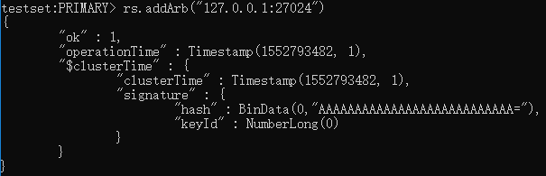

rs.status()

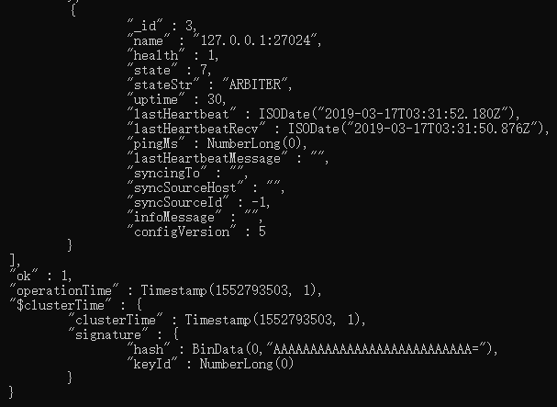

rs.conf()

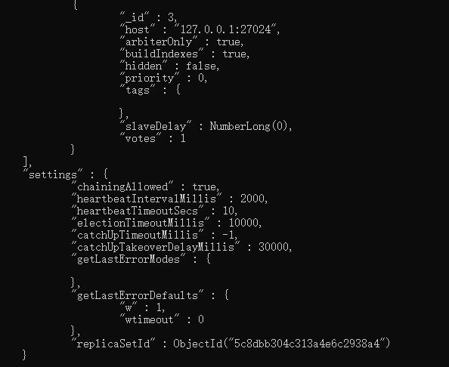

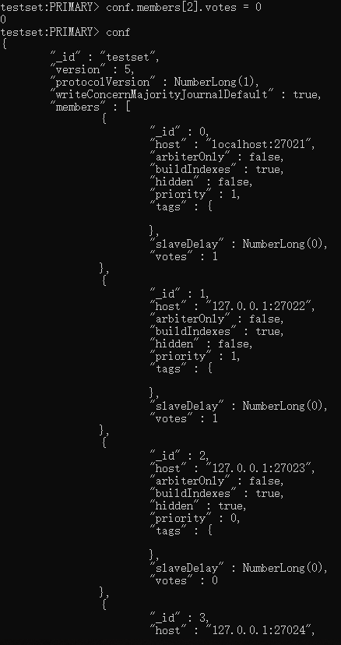

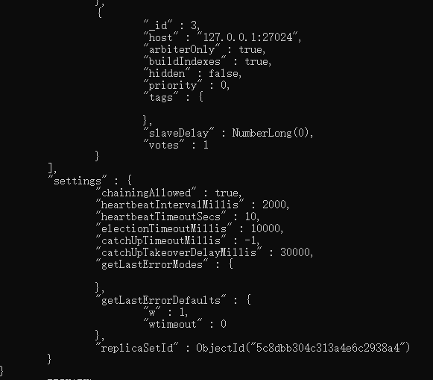

1. Replication example and result:

